**Testing:**

**Matching template test:**

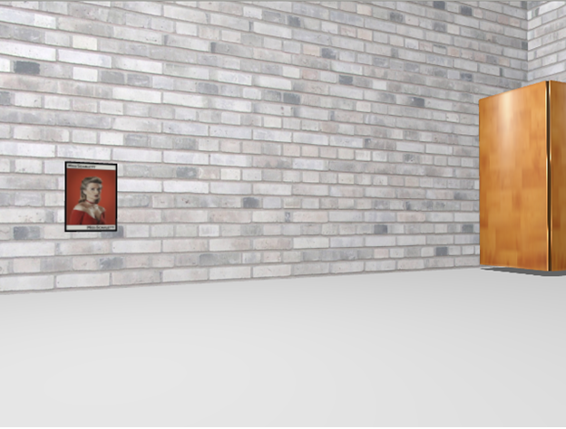 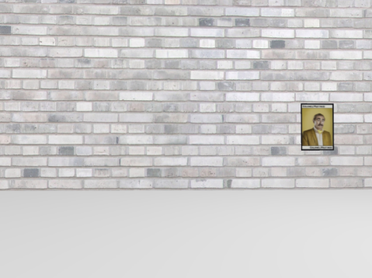

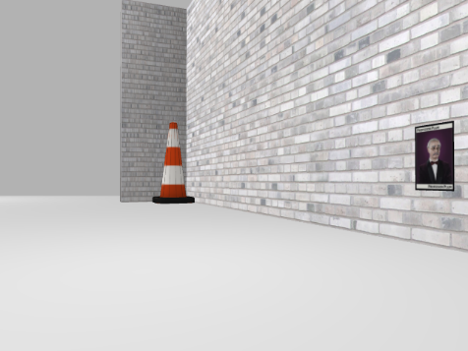 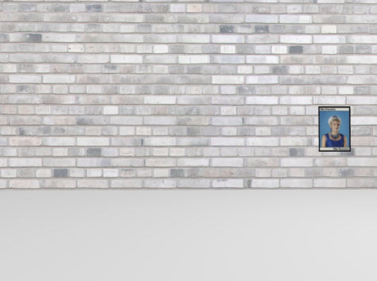

We changed the character images in the environment and adjusted the picture recognition threshold based on the results. After multiple test comparisons, we chose **0.65** as the matching threshold. When the suitability has exceeded the threshold, we consider that the character is found, and the character represented by the template with the highest match is the character name. As shown in the following figure, when the Cluedo character is detected, it will get four matching rates, corresponding to the template of the four characters. The first template has the highest matching degree, so the character name is considered ‘peacock’ here. After that, the program will stop and then automatically output image and character name.

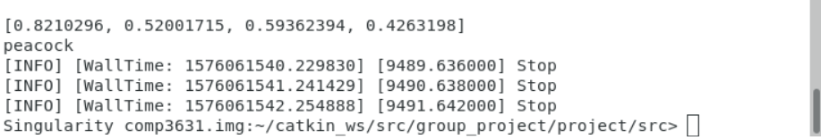

**Path Strategy test:**

As mentioned above, after the robot enters the room, the robot will take a certain path strategy to find the character. Therefore, the following tests are compared for path strategy one and path strategy 2. We tested the performance ten times in two different environments, and the results are as follows.

Original Environment:

|  |  |  |  |
| --- | --- | --- | --- |
|  | Average time | Find character | Character accuracy |
| Strategy 1 | 1m36s | 10/10 | 10/10 |
| Strategy 2 | 2m28s | 10/10 | 10/10 |

New Environment:

|  |  |  |  |
| --- | --- | --- | --- |
|  | Average time | Find character | Character accuracy |
| Strategy 1 | 5m7s | 2/10 | 2/2 |
| Strategy 2 | 3m42s | 10/10 | 10/10 |

The results show that in a simple environment without more obstacles, both strategies can accurately find and identify the character, and strategy 1 takes less time. However, in a complex environment, strategy 1 seems difficult to find the location of the character, while strategy 2 is more efficient, it can accurately find the character in a short time. Therefore, in pursuit of the recognition rate, we adopted Strategy 2 as the path strategy in the final version.

Final version test video：https://youtu.be/zhTh0-xikAU